**Monolithic Architecture:**

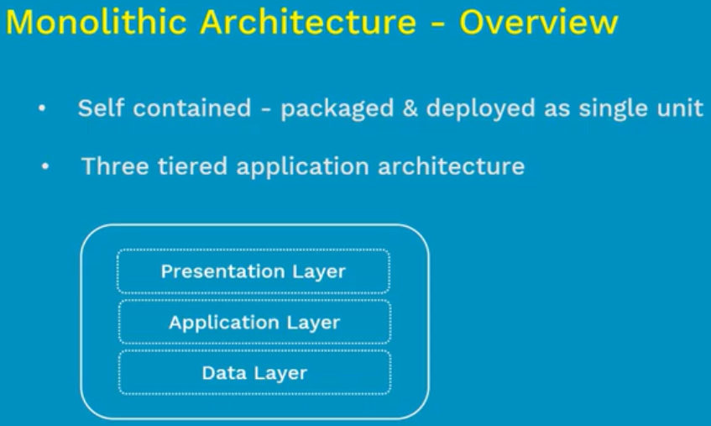

**Advantages and disadvantages:**

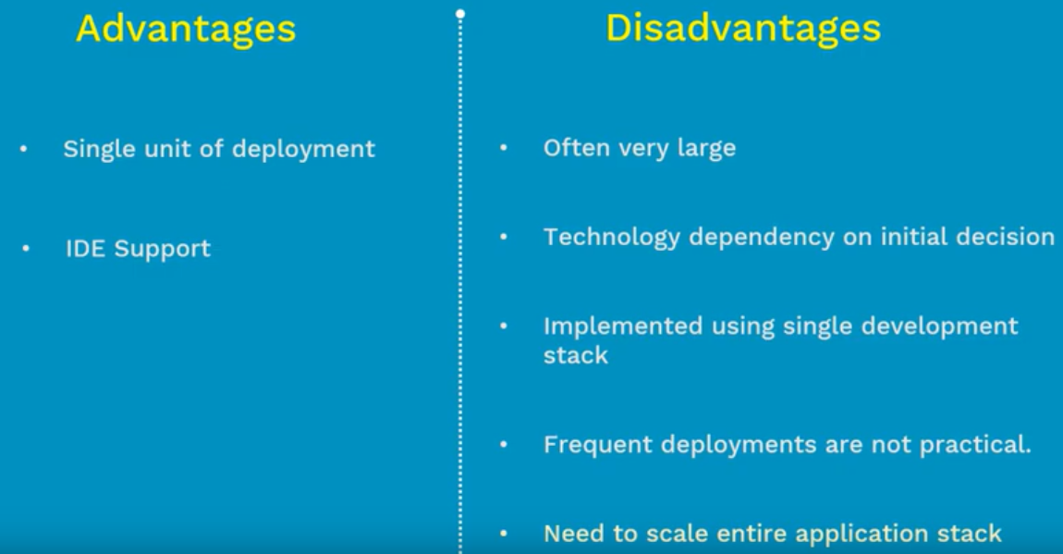



**Microservices:**

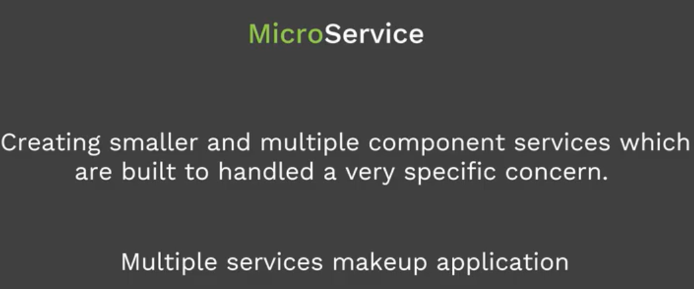

**Advantages:**

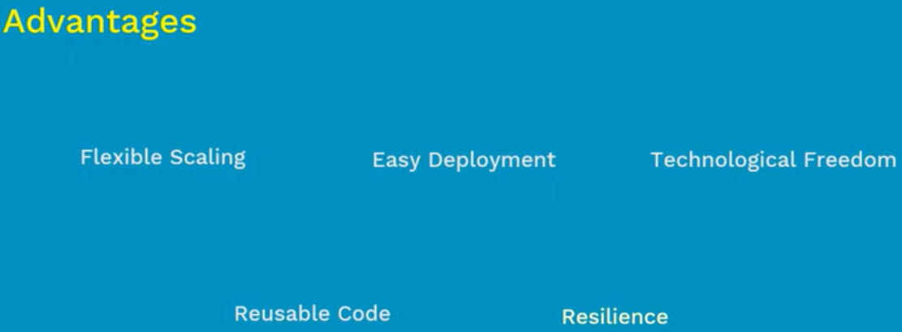

* Microservices are autonomous, means the service is build, deployed and operated without affecting the other services
* Each of this microservices will be having specific functionality and data
* Each microservice can be scaled up independently without depending on any other service
* As it is small and independent. So, the deployment is also very easy
* Microservice is technology independent. We can see any language or technology we want

**Disadvantages:**

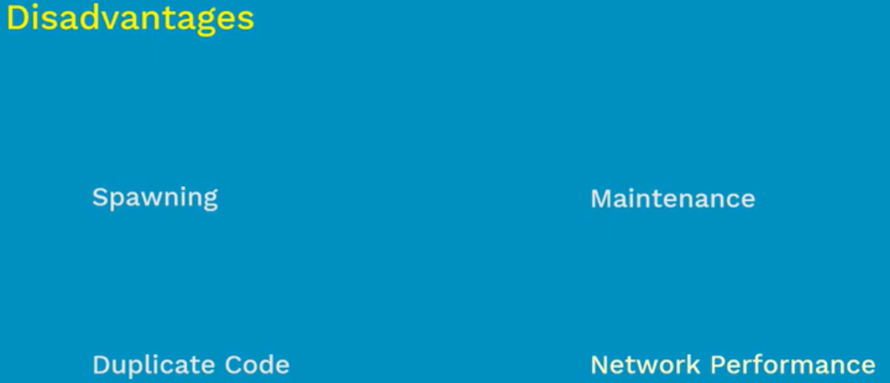

* Microservices are easy to handle but in some cases these services may grow high if it’s not properly planned
* It is easy to maintain the services when there are less. But it will be very difficult to manage them manually if there are many services

**Monolithic vs Microservices:**

